Hype Quick Ai

1.Registration Page

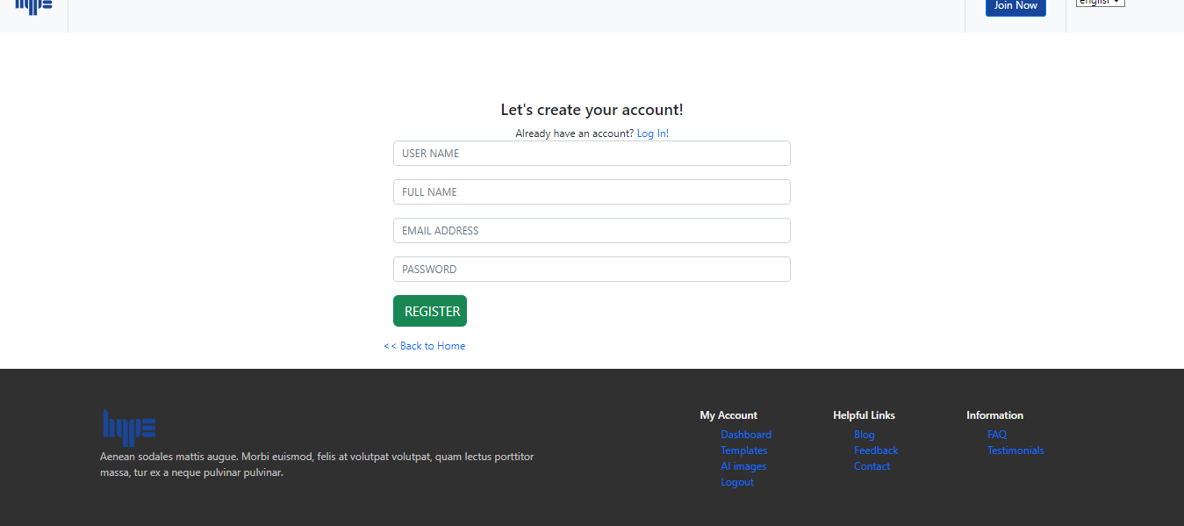

Vedio link: <https://drive.google.com/file/d/1rUi7fdcTZPPnFYz528CNpmngzViEyo48/view?usp=drive_link>

2.login page

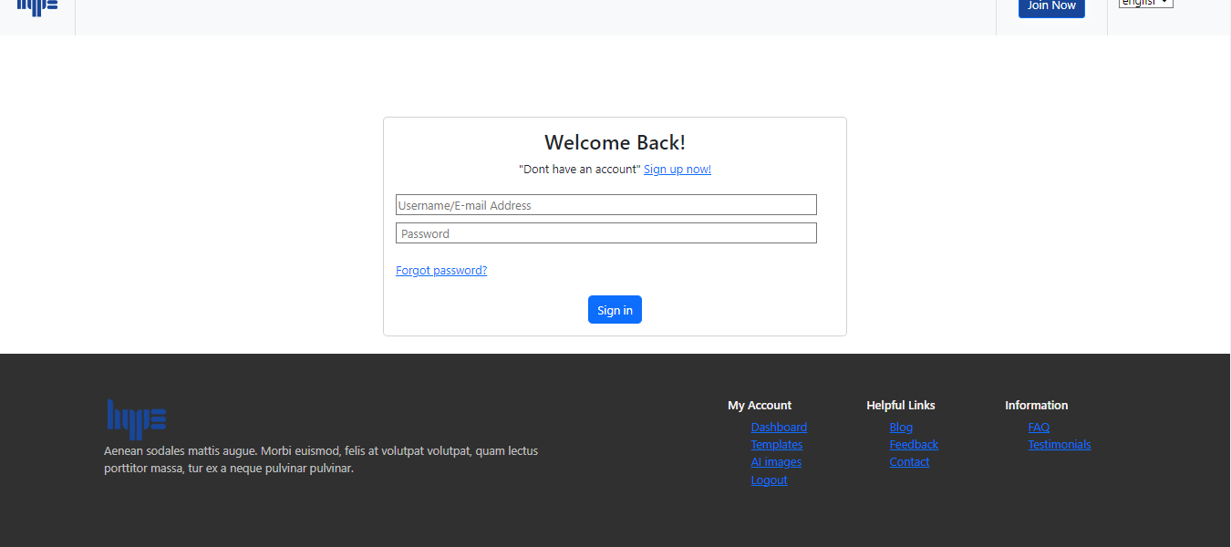

Vedio link:

<https://drive.google.com/file/d/18nlUEwCO4MYSCXw4l4k1wgBiSwqbNbbZ/view?usp=drive_link>

3.Dashboard page

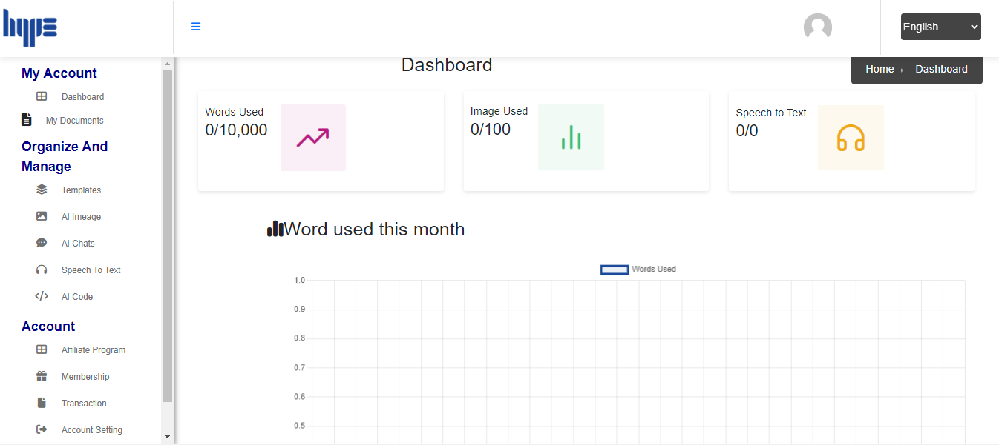

Vedio link:

<https://drive.google.com/file/d/1BuDWlGHeLfppFe1VKt1tH5p286-JNcZJ/view?usp=drive_link>

**sidebar pages**

4.All Document page

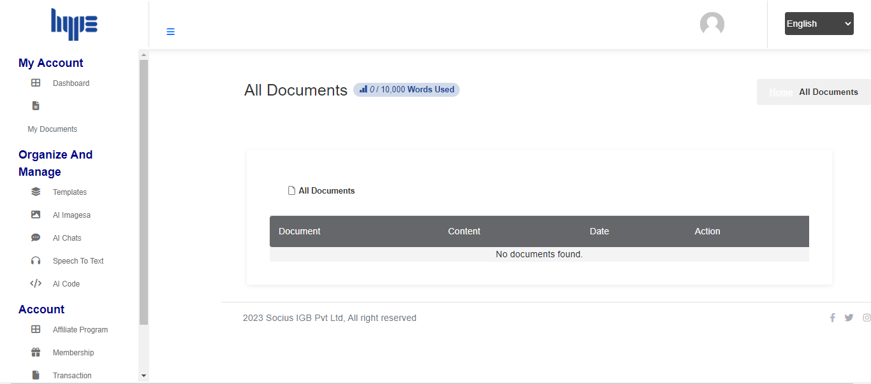

Vedio link: <https://drive.google.com/file/d/1M5HVe2EhEI4Gw2qcLprt_o9rISrgKJqi/view?usp=drive_link>

5.All Ai Images

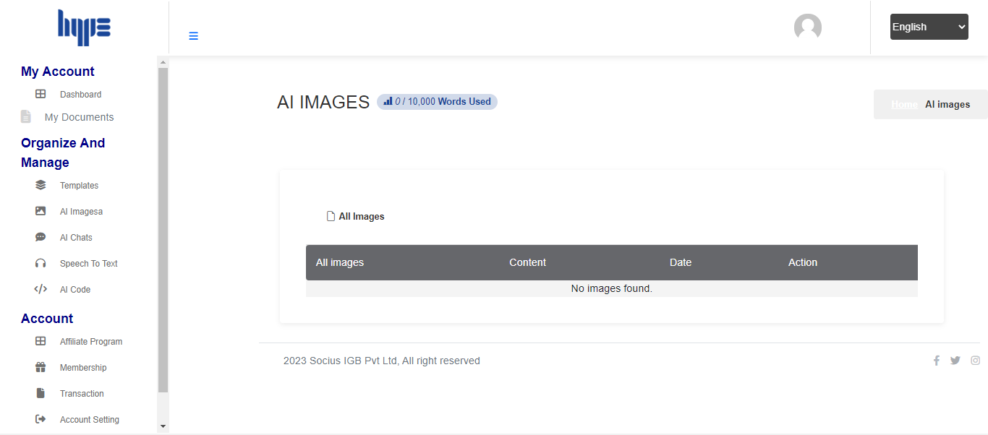

Vedio link:

<https://drive.google.com/file/d/1DfwGtNH5_2ccAWZIgXIblFewKb5LyC-o/view?usp=drive_link>

6.Templates

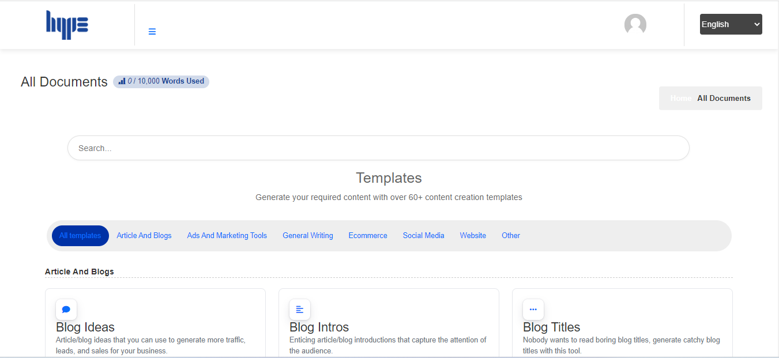

Vedio link:

<https://drive.google.com/file/d/1nFCZtkfzqZ03nbO8YpDXQie4sn_FlvnE/view?usp=drive_link\>

7.All images

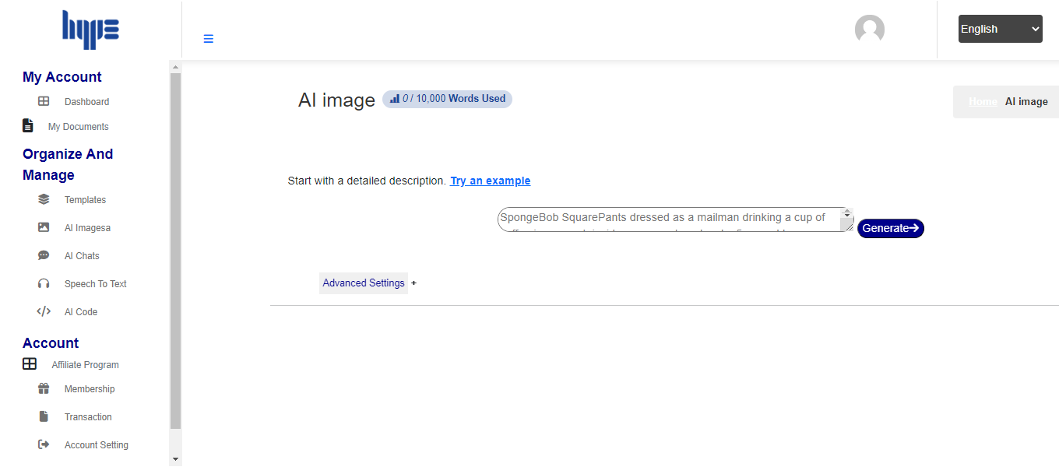

Vedio link:

<https://drive.google.com/file/d/11YLpLPE4DHskkDNQiRtV9m6EJTk9vbAb/view?usp=drive_link>

8.Ai chats

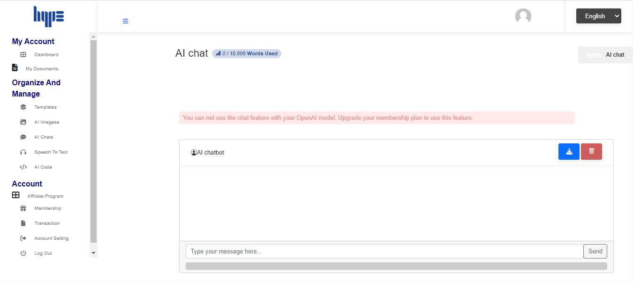

Vedio link:

<https://drive.google.com/file/d/1gCOvPkTJdehvMO7B9UaNTLrd1rIRaffl/view?usp=drive_link>

9.Speech to text

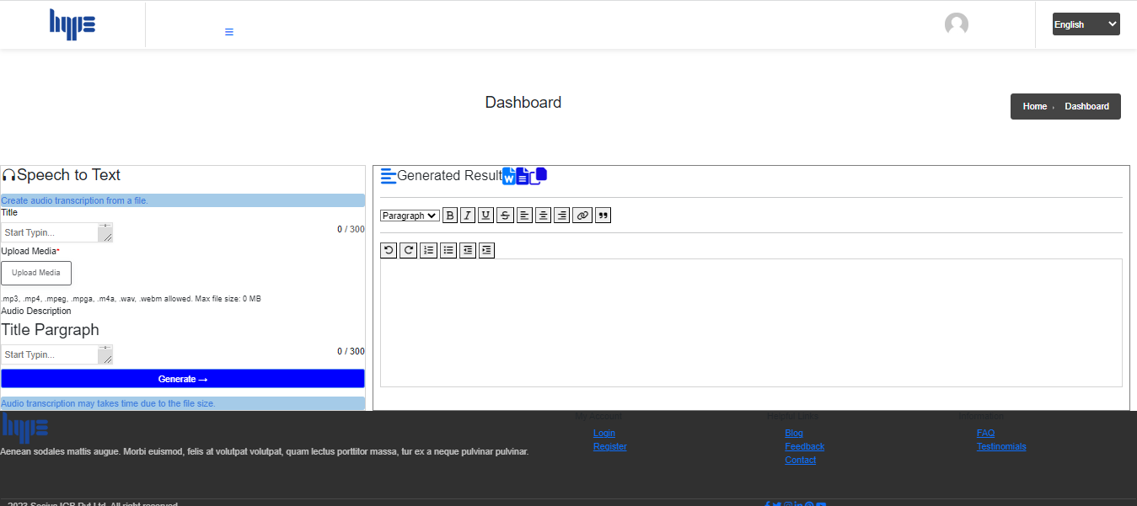

Vedio link;

<https://drive.google.com/file/d/1nwJ4A1HRcHBgO-O8DoFdQdCDv5wdl7zE/view?usp=drive_link>

10.AI Code

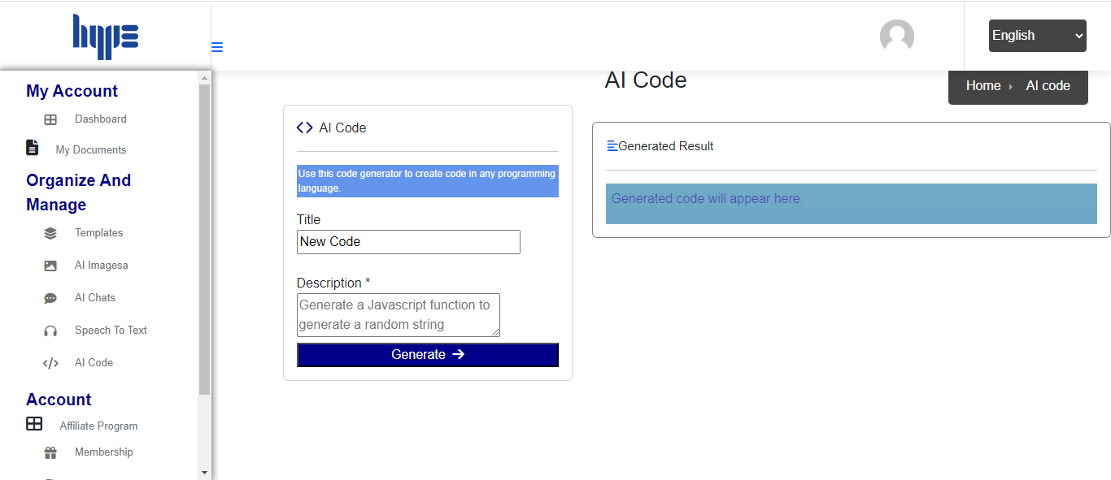

11.Affiliate program

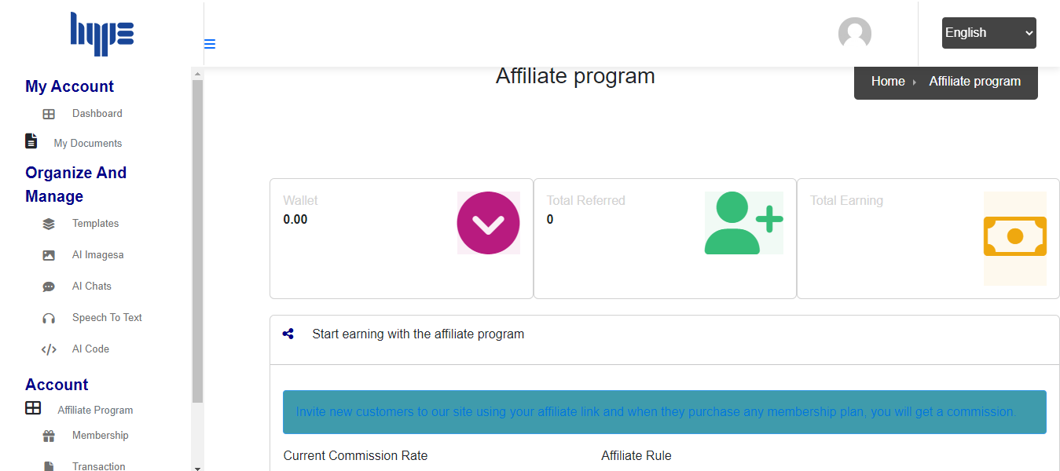

Vedio link:

<https://drive.google.com/file/d/1nwJ4A1HRcHBgO-O8DoFdQdCDv5wdl7zE/view?usp=drive_link>

12.Withdraw

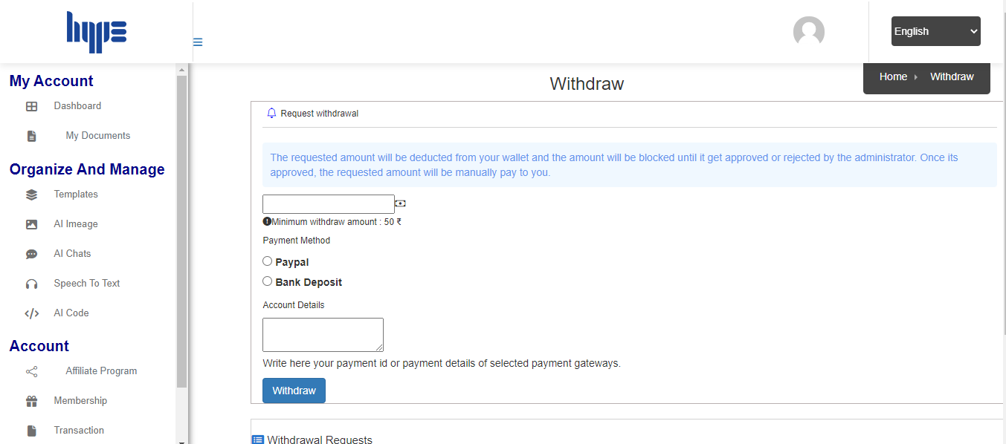

Vedio link:

<https://drive.google.com/file/d/1LVGg6gStiEcNfgtdm8eSOM5FkALbE7sP/view?usp=drive_link>

13.Membership plan

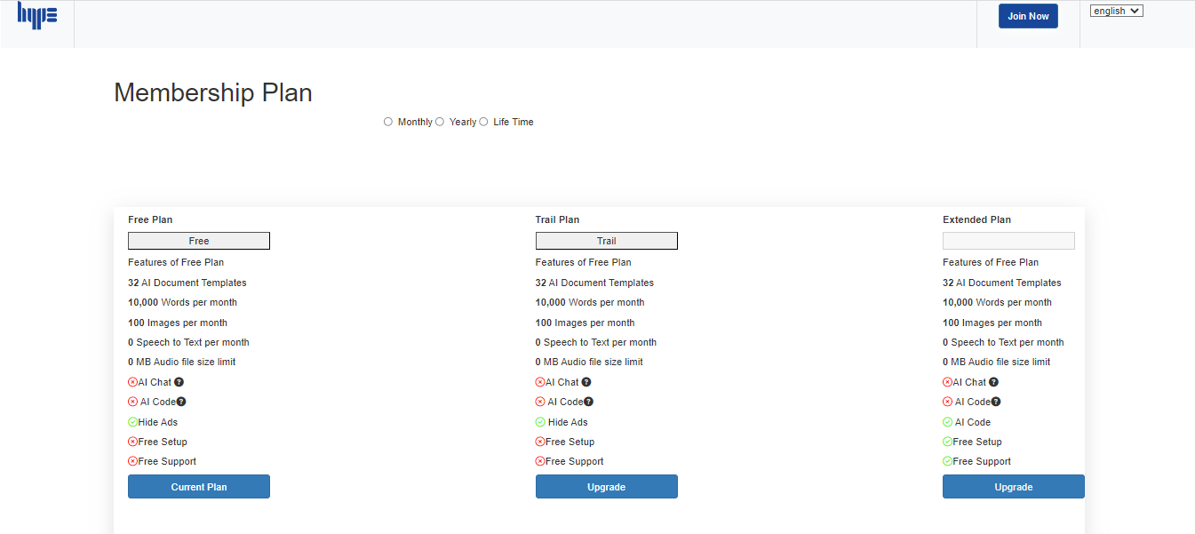

Vedio link:

<https://drive.google.com/file/d/1LVGg6gStiEcNfgtdm8eSOM5FkALbE7sP/view?usp=drive_link>

14.Transaction

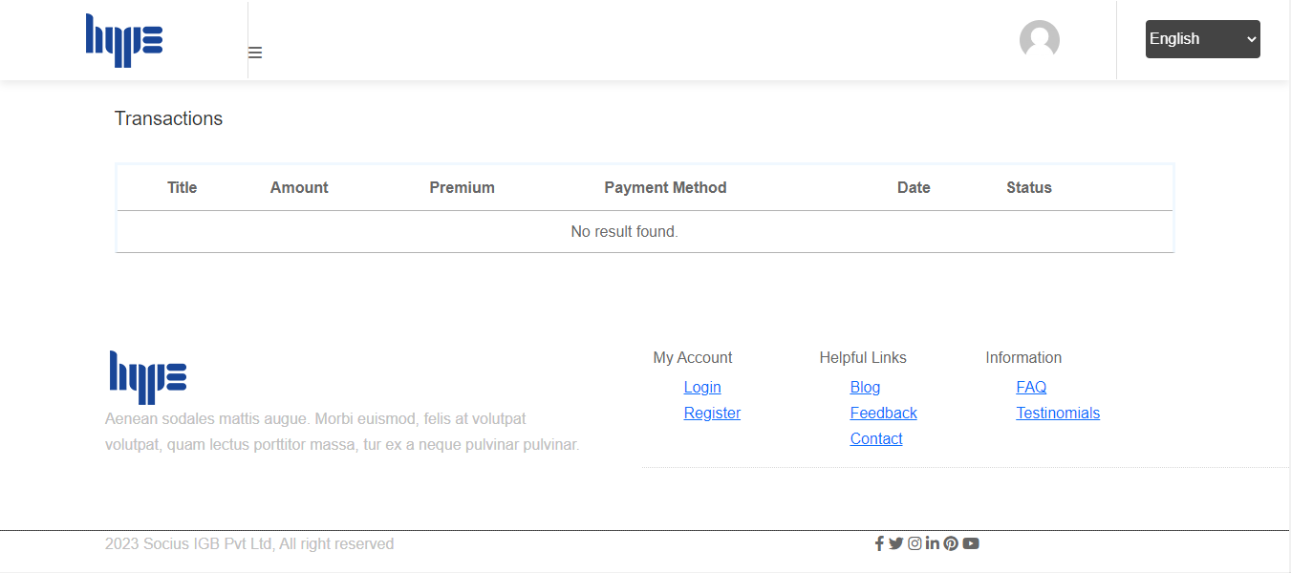

**Home page:**

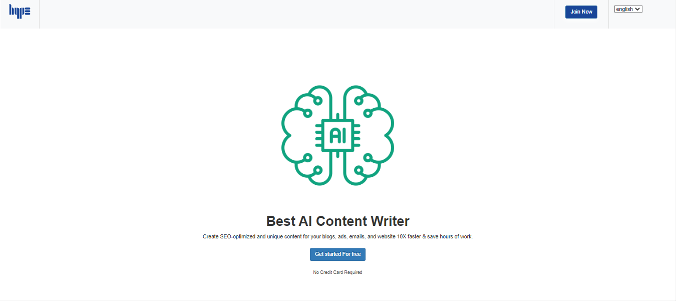

Vedio link:

<https://drive.google.com/file/d/1BVyW-UurxVUnJbqDt6etRbrJxn7DU2fN/view?usp=drive_link>

15.FAQ

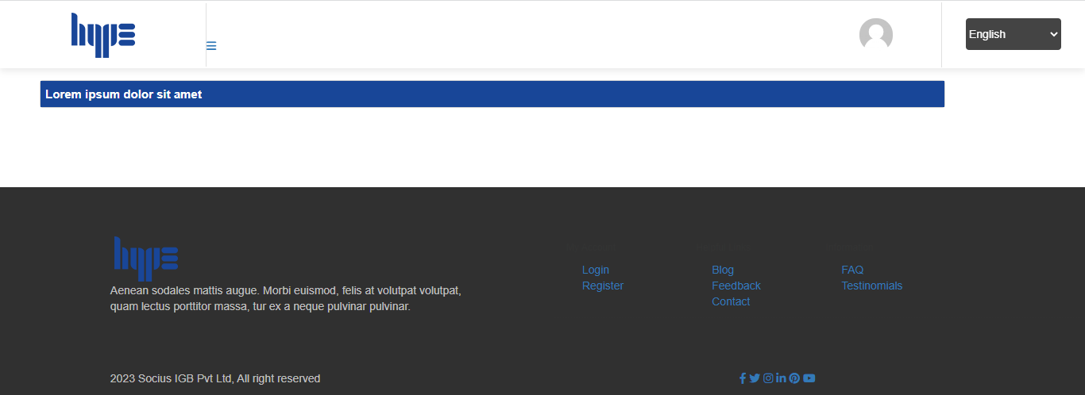

Vedio link:

<https://drive.google.com/file/d/1_j0n4vJ2pElk21p-fJaRJwhZJDV3psw9/view?usp=drive_link>

16. Current Plan

